  浙江大学信息与电子工程学院 | 集成电路原理与设计 | 2023年11月
2023-2024学年春夏学期 | 集成电路原理与设计 | 2023年11月

Exercise 5

Table 5.1
 |  | Typical Parameter Value
Parameter Symbol | Parameter Description | n-Channel | p-Channel | Units
V_{T0} | Threshold voltage(V_{BS}=0) | 0.7 | -0.8 | V
K | Transconductance parameter(in saturation) | 134 | 50 | μA/V²
γ | Bulk threshold parameter | 0.45 | 0.4 | V^{1/2}
λ | Channel length modulation parameter | 0.1 | 0.2 | V⁻¹
2|ϕ_{F}| | Surface potential at strong inversion | 0.9 | 0.8 | V
$$*K=μC_{OX}$$

  - Calculate the output resistance and the minimum output voltage, while maintaining all devices in saturation, for the circuits shown in Figure 5.1. Assume that i_{OUT} is actually 10μA. Use Table 5.1 for device model information. V_{bs}=0 V.
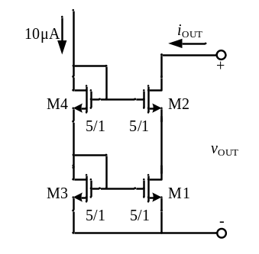
Fig 5.1
Answer:
$$V_{GS3}=V_{GS4}=\left(\sqrt{2×\frac{L}{KW}I_{D}}+V_{T}\right)=0.17+0.7 V=0.87 V.$$
$$g_{m2}=g_{m4}=\sqrt{2×\frac{KW}{L}I_{D}}=115.8{×10}^{-6}$$
$$r_{out}=r_{ds1}+r_{ds2}+g_{m2}r_{ds1}r_{ds2}.$$
$$r_{ds1}=r_{ds2}=\frac{1}{λI_{D}}=1{×10}^{6}$$
$$r_{out}=117.8{×10}^{6}$$
$$v_{out}=V_{GS3}+V_{GS4}-V_{T2}=1.04 V$$

- A reference circuit is shown in figure 5.2, assume that (W/L)₁=(W/L)₂= (W/L)₃=4, (W/L)₄=1, please calculate the symbolic expression of V_{REF}.（已知各管处于饱和区且各管阈值电压为Vt）
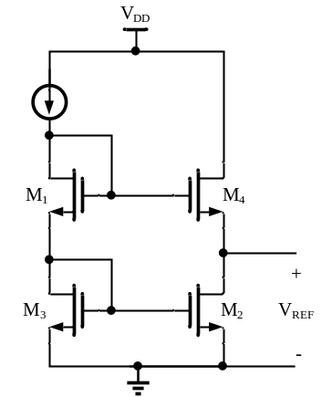

Figure 5.2
Answer:
$$V_{REF}=V_{GS1}+V_{GS3}-V_{GS4}$$
$$V_{REF}=V_{ON1}+V_{T1}+V_{ON3}+V_{T3}-V_{ON4}-V_{T4}$$
$$V_{T3}=V_{T4}$$
$${V_{ON4}=2×V}_{ON1}{=2×V}_{ON3}$$
$$V_{REF}=V_{T1}$$

- As the circuits shown in Figure 5.3, I_{REF}=0.3mA and γ=0. Using the model parameters in Table 5.1,
(a) Calculate the voltage V_{b} when V_{X}=V_{Y}.
(b) If V_{b} is 100mV smaller than the value in (a), calculate the deviation of I_{out} from 300μA.
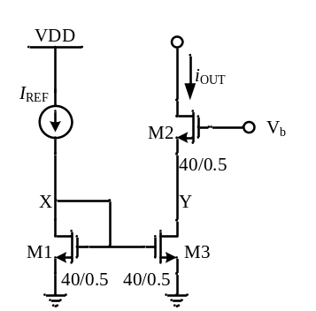
Figure 5.3

Answer:
- $V_{GS1}=\left(\sqrt{2×\frac{L}{KW}I_{REF}}+V_{T}\right)=0.24+0.7=0.94 V. V_{b}=2×V_{GS1}=1.88 V.$
- $λ\left(L=0.5u\right)=2×λ\left(L=1u\right)=0.2V^{-1}$
$$I_{out}=I_{REF}\frac{1+λ{(V}_{GS1}+∆V_{b})}{1+λV_{GS1}}，∆ I_{out}=I_{REF}\frac{λ∆V_{b}}{1+λV_{GS1}}=-5.05{×10}^{-6}$$

- Design M3 and M4 of Figure 5.4(a) so that the output characteristics are identical to the circuit shown in Figure 5.4(b). It is desired that i_{OUT} is ideally 10uA.
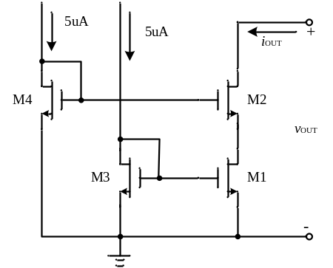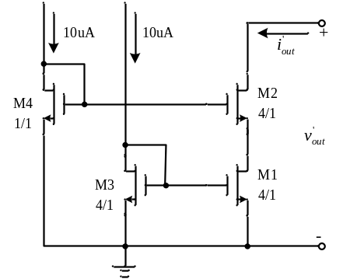
- (b)

Figure 5.4
Answer:
- $V_{GS1}=V_{GS3},V_{GS2}=V_{GS4}. I_{3}= I_{4}=5uA，I_{out}=10uA,we must have（\frac{W}{L}）_{1}=2×（\frac{W}{L}）_{3}，（\frac{W}{L}）_{3}=2/1.$
In（b）$i_{3}= i_{4}=10uA=i_{1}$，$（\frac{W}{L}）_{4}×V_{Dsat4}^{2}=（\frac{W}{L}）_{1}×V_{Dsat1}^{2}{,V}_{Dsat4}^{}={2×V}_{Dsat1}^{}$
$$V_{GS4}=V_{T}+V_{Dsat4},V_{GS2}=V_{T}+V_{Dsat4},V_{out}>V_{GS2}-V_{T}=V_{Dsat4}=2×V_{Dsat1}$$
In（a）$I_{3}= I_{4}=5uA=2×I_{1},（\frac{W}{L}）_{4}×V_{Dsat4}^{2}=\frac{1}{2}（\frac{W}{L}）_{1}×V_{Dsat1}^{2}$
$$because, \frac{V_{Dsat4}}{V_{Dsat1}}=\sqrt{\frac{1}{2}×（\frac{W}{L}）_{1}/（\frac{W}{L}）_{4}}=2,（\frac{W}{L}）_{4}=\frac{1}{8}×（\frac{W}{L}）_{1}=1/2$$

